**Instrumentation Room**

|  |  |
| --- | --- |
| Instrumentation Centre - Eqiupment :    1. UV - VIS Spectro Photo Meter  2. P.C. with the Printer HP make  3. Photographic Camera SLR with Microscope  4. Tirnocular Microscope  5. P.C.P. Unit Mastre Cycler Personnel Ependorf     Make  6. Higher Performance Liquid Chromatography  7. Basic baby fermentor  8. Fully Auto Hematology Analyzer  9. Urine Analyzer  10. Water Analyzer  11. High Power Binocular Microscope - Labomed Binocular Stereo Zoom Microscope Model CSM 6B. | 1  1 |

|  |
| --- |
|  |

* [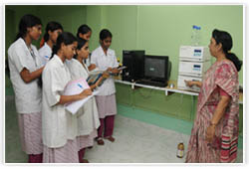](http://www.chsd-theresacollege.net/v2/instrumetroom.html)